**Part A: DIVE Scoring Program**

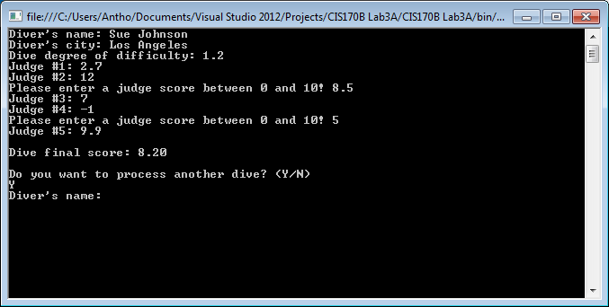

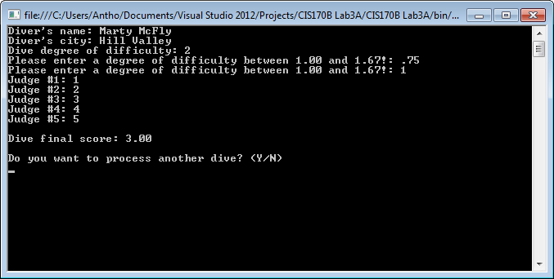

// ---------------------------------------------------------------

// Programming Assignment: LAB3A

// Developer: Anthony Meunier

// Date Written: 7/27/2014

// Purpose: DIVE Scoring Program

// ---------------------------------------------------------------

using System;

using System.Collections.Generic;

using System.Linq;

using System.Text;

using System.Threading.Tasks;

namespace CIS170B_Lab3A

{

class Program

{

static void Main(string[] args)

{

//declare variables

string name, city, again;

double degree = 0, judgeScore = 0, high = -0.01, low = 10.01, totalScore = 0;

//get diver information

do

{

Console.Write("Diver's name: ");

name = Console.ReadLine();

Console.Write("Diver's city: ");

city = Console.ReadLine();

Console.Write("Dive degree of difficulty: ");

degree = Convert.ToDouble(Console.ReadLine());

//validate degree of difficulty

while (degree < 1.00 || degree > 1.67)

{

Console.Write("Please enter a degree of difficulty between 1.00 and 1.67!: ");

degree = Convert.ToDouble(Console.ReadLine());

}

//prompt user to enter five judge's scores

for (int i = 0; i < 5; i++)

{

Console.Write("Judge #{0}: ", i + 1);

judgeScore = Convert.ToDouble(Console.ReadLine());

//validate judge's scores

while (judgeScore < 0 || judgeScore > 10)

{

Console.Write("Please enter a judge score between 0 and 10! ");

judgeScore = Convert.ToDouble(Console.ReadLine());

}

//accumulate and find total score

totalScore = totalScore + judgeScore;

//find high and low scores

if (judgeScore > high)

{

high = judgeScore;

}

if (judgeScore < low)

{

low = judgeScore;

}

}

//calculate and display final score

Console.WriteLine();

Console.WriteLine("Dive final score: {0:f2}", (totalScore - high - low) / 3 * degree);

//check for sentinel value

Console.WriteLine();

Console.WriteLine("Do you want to process another dive? (Y/N)");

again = Console.ReadLine().ToUpper();

} while (again == "Y");

//keep console display open

Console.ReadLine();

}

}

}